**USA VISA Checklist and Tips**

Internal notes: yellow highlight

ZD fileds: Blue

Macros/emails: Red

UCC status: Green

Other action: black

***Table of contents (hyperlinked):***

* *Initial action*
* *\*If* ***more information*** *is required*
* *If the* ***MRV is paid****, but appointment is not scheduled (when it needs to be).*
* *After the appointment/s is/are* ***scheduled*** *(if not waived entirely, including all appointments)*
* *If the appointment date is* ***changed*** */ if the appointments are rescheduled*
* *If all appointments are* ***waived***
* *Appointment* ***Reminder***
* *After they attend the appointment(s) / send the documents* *(Issued / Refused / Administrative processing)*
* *If the client requests a* ***refund***
* *Reminders and tips*

**-------------------------------------------------------------------------------------------------------------------------------**

**Initial Action**

* Open the ticket, set yourself as the **ticket owner** in ZD fields
* Check if there are any **related tickets**
* [**Review**](https://govassist.atlassian.net/wiki/spaces/DOC/pages/23237987126/Detailed+UCC+Review)the application in the UCC
* Check if the client previously contacted us/sent us any messages and respond (you can do that by adding your response in the initial response, more info required, or escalations macros (according to the situation).
* Check if the clientspeaks another languageand include **translations** in the **messages and internal notes.**
* Send the **initial response** macro*unless more info is needed
* Include your **Calendly** link
* **Process** the DS-160 form *Run the bot or fill it out manually if needed (select 'Processed manually' UCC status if so).
* Create an **embassy account** for the client (A, A(new), B)
* Add an internal note with t**he screenshot** **of the account'**s fist page **and** applicant details & questions page along with the **account credentials** and state 'embassy account created'*
* Add embassy account **credentials** in ZD fields (left side).
* Mark the UCC application as **'Embassy account created'**\*
* Send the correct ['**ready for...**'](https://govassist.atlassian.net/wiki/spaces/DOC/pages/23237988036/USA+VISA+-+Ready+for+...+Situations) Macro, set to pending
* Send the necessary **documents / files** via Document handler
* Mark ZD pending offset reason as ' Waiting for Client - Pending'

**\*If more information is required**

* Mark the UCC as 'More information required'
* Include the screenshots / notes of what information is required or what needs to be corrected or double-checked
* Send the 'More information required' macro
* Include your **Calendly** link
* Mark ZD pending offset reason as 'Waiting for Client - Pending'
* Post the screenshot of the current time for the client (if you can't call them within your shift, add the screenshot showing that, you can use [the time buddy](https://www.worldtimebuddy.com/), and you can trade the ticket)
* Call the client
* Include the 'Call summary:...'

*if the client has their own account, mark the UCC as 'personal embassy account' and send VISA::1.Ready for::USA VISA: Ready for interview scheduling (IF CLIENT HAS AN EMBASSY ACCOUNT) macro

**If the MRV is paid, but appointment is not scheduled (when it needs to be).**

* Include the screenshot from the embassy account showing that the MRV is paid and available appointment dates.
* Send a message to the client or call the client to **remind** them, telling them that their payment is registered in the system and that they can schedule it.
* If needed, remind them that appointments are always changing and that it's best to schedule as soon as possible. Also mention that it is possible to reschedule appointments after they are scheduled. Mention the rescheduling limit as well just as a heads-up.

If MRV is paid but receipt is **not registered,** refer to this it has pictures <https://govassist.atlassian.net/wiki/spaces/DOC/pages/23237988854/Contacting+the+Embassy>

And to the links in the appointment scheduling embassy website ('Contact us' part, and scroll to payment issues section)

**After the appointment/s is/are** [**scheduled**](https://govassist.atlassian.net/wiki/spaces/DOC/pages/23237988290/Interview+Scheduled) **(if not waived entirely, including all appointments)**

* Post a screenshot from the embassy account showing the scheduled appointment
* Mark the UCC application as '**interview scheduled** or '**biometrics appointment scheduled**' or '**drop-off appointment scheduled**'
* Add the **appointment date** in the correct ZD field
* Make sure the **travel date** ZD field is the same as it is in UCC and that the date is in future
* Send the 'Interview Scheduled / Drop off appointment scheduled/ Biometrics Appointment Scheduled' macro
* Send the documents from the UCC Document Handler (Appointment confirmation, MRV receipt, DS160 form and DS160 confirmation page)
* Mark ZD pending offset reason as 'Interview scheduled' or 'Interview Waiver/**biometrics** - On Hold'
* If the client needs an earlier appointment but no urgent need to travel, mark ZD field ' Requires earlier appointment' and keep checking and posting appointment screenshots

**If the appointment date is changed / if the appointments are rescheduled**

* Add the internal note with the screenshot showing the change
* Change the appointment date ZD field
* Send the correct appointment details to the client
* Send the new appointment confirmation page

**If all appointments are** [**waived**](https://govassist.atlassian.net/wiki/spaces/DOC/pages/23237988457/Interview+Waiver)

* Post a screenshot from the embassy account showing that the interview is waived
* Change the UCC application status to '**Interview Waiver'**
* Send the **'Interview Waiver'** macro
* Mark ZD pending offset reason as 'Interview Waiver/**biometrics** - On Hold'
* Send the documents from the UCC Document Handler (Confirmation and Instructions, **Courier in receipt**, MRV receipt, DS160 form and DS160 confirmation page)

**Appointment Reminder**

* Before the appointment double-check the **travel date, passport expiration date**, and the **appointment date**.
* If anything needs changing, ask the client by sending '**we need to update the DS160 form'** macro, call the client, and reprocess the form. Change the macro according to the situation.
* Include the **screenshots** of the above-mentioned things in the IN to show the travel date is after the appointment, the passport will not expire before the appointment or 6 months after the trip (check 6 months club), and that the appointment date is still scheduled to the same date in the account.
* About 7 days before the appointment, send the **'Appointment Reminder'** macro
* Re-send the necessary documents via doc handler

**After they attend the appointment(s) / send the documents**

* Check the status of their visa on CEAC* (see the actions below depending on the status)
* Check the embassy account for any new updates from the embassy in the 'details' section and scroll to the 'Follow-up Action History'
* Update the client on the status of their application

**If the application is Approved\***

* Post a screenshot of their visa status from CEAC (in the internal note)
* Change the UCC application status to approved*
* Send a personalized message about the status and wait for the visa status to change to 'Issued'

*When visa is approved but not issued, you will see this in the status

"The consular officer has approved your application subject to final processing by the consular section that is necessary to issue your visa. When that processing is complete, the status will change to "**Issued**". However, a final screening step must still be completed prior to issuance that could lead a consular officer to conclude that you are not eligible for a visa. If that occurs, the consular officer will notify you that your application has been denied and your status will change to "Refused"."

*You can also wait a bit for the status to change to Issued

**If the application is Issued**

* Post a screenshot of their visa status from CEAC (in the internal note)
* Change the UCC application status to '**Visa approved**'
* Post a screenshot from the embassy account showing passport delivery details or the lack of at that moment.
* Send the 'Final decision:: **USA Visa Issued**' macro
* Checkmark ZD field Last Step Reached? (if not selected automatically)
* Select ZD field Visa Issued 'Yes' (if not selected automatically)

**Refused under Administrative Processing**

* Post a screenshot of their visa status from CEAC (in the internal note)
* Change the UCC application status to '**Administrative processing**'
* Include a screenshot from the embassy account showing the embassy account first page as well as the 'details' section under **'Follow-up Action History**' (Embassy B)
* Ask the client if they received any 221(g) letters/papers or instructions form the embassy / consular officers asking them to take a follow-up action
* Help the client follow the appropriate steps specified in the letter*

*If requested, you can send the additional requested documents by following the instructions from the **Visa Navigator** (V11 - REQUESTED DOCUMENTs - FULL NAME (this is the email subject)) or for old embassy A, you can use the '**provide feedback** option' and select the appropriate subject and email format, and attach the documents (221(g)...)

* Mark ZD pending offset reason as ' Administrative Processing - On Hold '
* Keep checking the visa status until the final decision is made

<https://govassist.atlassian.net/wiki/spaces/DOC/pages/23237988854/Contacting+the+Embassy>

**If the application is Refused**

* Change the UCC application status to **'Visa Rejected'**
* Post a screenshot of their visa status from CEAC (in the internal note)
* Send the 'Final decision:: **USA Visa Refused**' macro
* Select ZD field Visa Issued 'No' (if not selected automatically)
* Solve the ticket

**Passport Delivery**

* Post a screenshot of their passport delivery status from the embassy account and/or the provided link we receive regarding the delivery / passport tracking (in the internal note)
* Inform the client*

*If you get the passport delivery details in before sending the 'Issued' macro, you can include them in that macro in the designated section (read the macro)

*If you get the notice after the issued macro, write a message informing the client about it.

* Change the UCC application status to **'passport in transit'** if it's in transit.
* Select ZD offset reason field to 'Passport Delivery - On Hold'

**\*If the clients have to schedule a passport-pick up appointment**

* Use the 'USA VISA: Please schedule your passport-pick up date' macro
* After it is scheduled, add a screenshot of the scheduled appointment from the embassy account (in the internal note)
* Use the 'USA VISA: Passport pick-up date scheduled' macro
* Select ZD appointment date field to a new appointment date
* Send the appointment confirmation for passport pick up appointment via Document Handler
* Once they get their passport, and you have proof/confirmation post the screenshot of your proof from the embassy account or the website for passport tracking in the internal note (or have the client's confirmation)
* Use the 'USA Visa: Passport Received' macro
* Change the UCC application status to '**Passport Received'**
* Solve the ticket

**If the client requests a refund**

If **unprocessed** (ready for... macro is not sent) and payment is **not captured**

* Check for duplicate payments and related tickets
* Cancel the payment authorization(s) through the link(s) in the ticket
* Send the ' Cancel Authorization (All Products)' macro
* Mark ZD field for 'Refund reason' accordingly, if not know, select 'other'
* All other ZD fields and the UCC application will be marked automatically, you can double-check and correct if you notice something awry.
* Solve

**When escalating to the Billing Team**

* Check for duplicate payments and related tickets (escalate all related sales tickets)
* Send the 'Acknowledge Escalation to Billing'
* Mark ZD field for '**Refund reason**' accordingly, if not know, select 'other'
* Mark ZD field for +**\*Refunded**' - 'Refund was requested'
* Mark ZD field for **Application status** as 'Processed' or 'Unprocessed'
* Use the 'Escalate to Billing team macro' and **edit** that internal note Internal note accordingly
* Set the correct **ticket priority** field according to client's mood and urgency before clicking submit
* Change the UCC application status to 'Escalated'

**Reminders and tips:**

* If you use the **wrong macro** without sending it, to correct it you need to delete the message and refresh the page, then use the correct macro so that the ZD tags are applied correctly. Don't apply a macro over the macro.
* You can double-check the documents / files in UCC by clicking **'preview'** before sending the files. If it fails to open it, it means you have to reupload that file.
* When asked a question, in the reply **rephrase** **the question** and answer it properly
* Don't send the same macros and robotic emails repeatedly, **edit/rephrase** them each time, you can use an AI / quillbot for that, but make sure that the sentences are grammatically correct, and the tone is polite.
* If you don't want an application in UCC to be **deleted** after the ticket is solved/refunded/unpaid, you can set the immunity to **'true'** and it won't get deleted, just make sure it says 'true', click the orange man and check what message pops up.

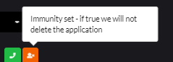

* If you **reprocess** the UCC/DS160 application you have to change the UCC status every time to what it was before (interview scheduled, embassy account created, etc.) and send the client that DS160 form and confirmation page.
* Every time you wish to make a change to ZD **fields**, you will need to **submit** the ticket as open/pending/on-hold for the changes to apply on that ticket
* If you **reprocess the DS160 after the appointment is scheduled**, change the DS160 number/application ID in the embassy account (if possible) then download and send the new appointment confirmation page with that application ID inside it (where the barcode is). If it's not possible to change it, send the old (the one with the number/ID in the appointment confirmation page/waiver confirmation page, and new DS-160 Confirmation pages to the client and tell them to bring both.
* Ask identity identification questions when you call, or when chatting when needed.
* If you do something out of the ordinary/that is not included in the regular procedure, always explain your actions in the internal note (IN). Note for the QA: ... or Note: ...
* If you are answering questions where you had to do some research, you can add the links and screenshots in the IN showing you provided the correct information to the client and where you found it. Make sure that the info is from the **official websites** (.gov, [traveldocs](https://www.ustraveldocs.com/), [USCIS](https://www.uscis.gov/), [travelstate.gov](https://travel.state.gov/content/travel.html), [CBP,](https://www.cbp.gov/) etc.). Most gov websites have search bars inside them, you can use them. Also Ctrl+F or F3 can help in finding specific words/phrases.
* When contacting the embassy or a consular section via email, check if they have the **VISA NAVIGATOR** instructing you how to message them and exactly which email subject and format to use for each inquiry/request. - screenshots below

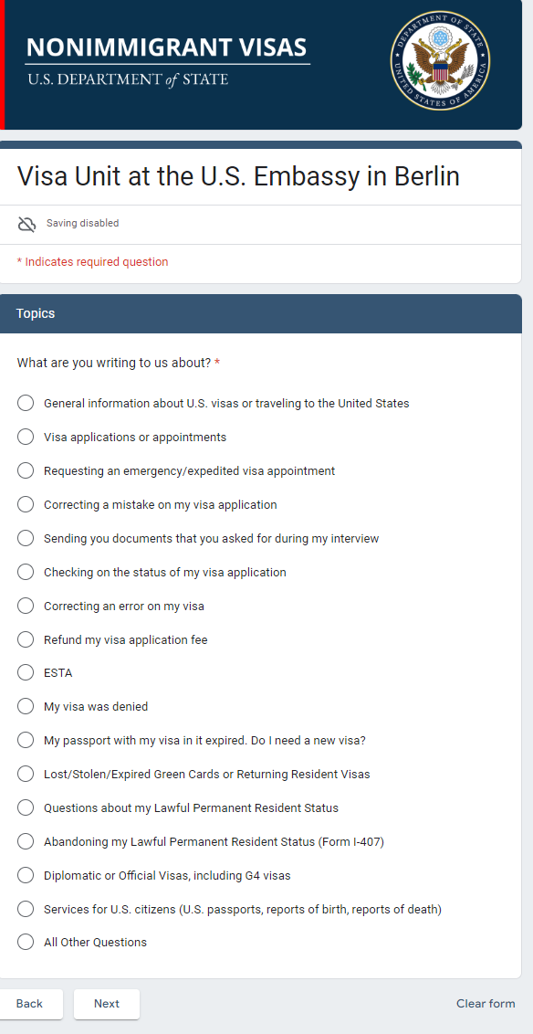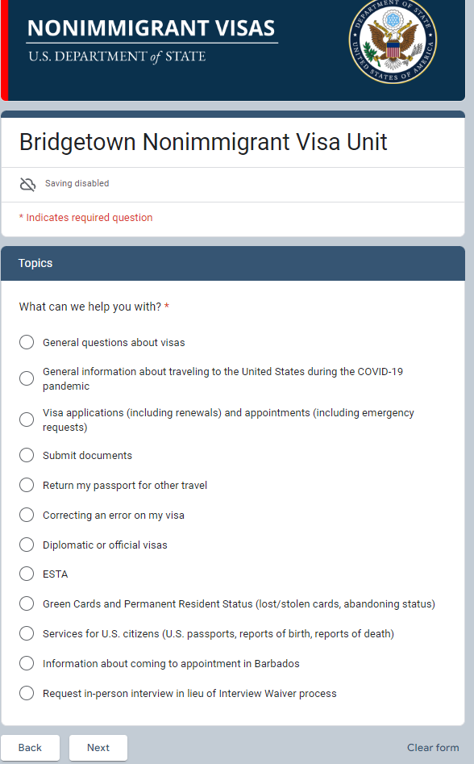

* You can find a lot of relevant information and contact information on B embassy websites if you just scroll down all the way, you will see the relevant links
* You are only allowed to send links from the official websites to the client, if you decide to include them.
* When reviewing the UCC, pay special attention to the US contact, travel purpose, **travel date,** passport type, **passport expiration date** and number, other travelers, nationality and residence, previous US visas, security questions, if they said they traveled to the US within the last 5 years add it to the courtiers traveled if missing.
* When you see a **group application** make sure that the data between the applications is consistent, and that they are included in 'other travelers' if they are travelling together.
* If the client asks you something, when answering rephrase their question to them to make sure that you understood them correctly and that you listened/read their concerns.
* Offset rules: <https://govassist.atlassian.net/wiki/spaces/DOC/pages/23237989246/Pending+On-hold+Offset>
* You can change ZD to either close the tab or stay on that ticket once you click 'submit here

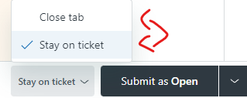

* You can change the client's name (change the letters from CAPITAL to regular) like so, so that you don't have to type it/paste it every time. You can also add an email or a phone number in the fields once you click that.

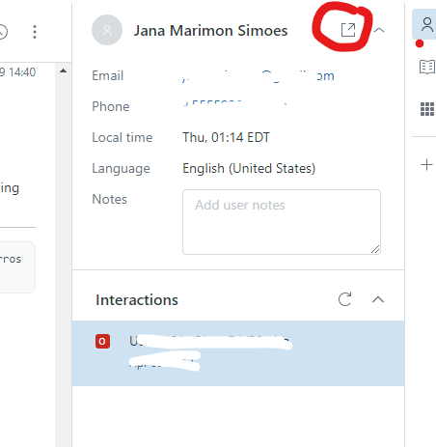

* Create personal views or ask your manager about creating personal ZD views according to your preferences.

Sarrah Kuršumović :')

**S**